

APPRECIATIVE INQUIRY GATHERING FINDHORN 12TH–14TH SEPTEMBER 2025
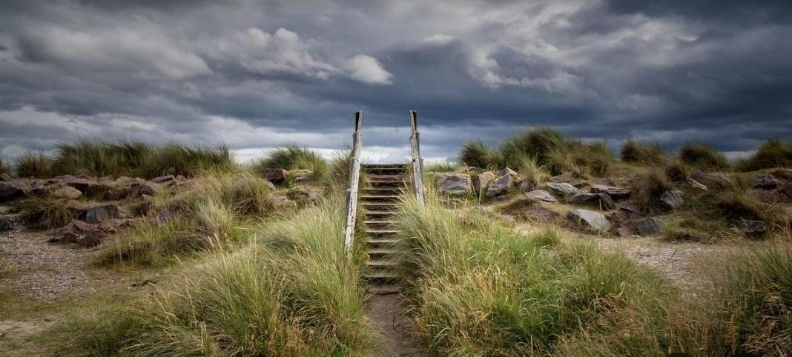
We would like to invite you to join us in a three-day gathering of Appreciative Inquiry practitioners in Findhorn, Scotland on 12th – 14th September 2025.
The gathering is being organised by the International Alliance for Appreciative Inquiry: an alliance between Appreciating People, Alder Advice and Appreciating Church in the UK, Inspiring Partners in Spain and Wise-Ing in Italy.
The Findhorn Gathering will offer conversations to deepen our understanding of Appreciative
Inquiry by bringing together those who are curious to discover more about Appreciative Inquiry alongside experienced practitioners. This collective wisdom, inspiration, energy and compassion will be combined in intentional and serendipitous ways.
There are places for approximately 30 appreciative inquirers at the gathering. We hope to welcome a diversity of attendees across different sectors, disciplines and locations with the aim of stimulating innovative cross-boundary conversations. Attendees so far include practitioners from organisational development, health and social care, education, planning and church based in the UK, Spain, Italy and The Netherlands.
There will also be an opportunity to explore this spectacular corner of Scotland including a tour of the Findhorn eco-community. www.ecovillagefindhorn.com
Dates and times:  - Thursday 11th September –  Participants arrive in Findhorn ready to start at 09.30 on Friday.  - Friday 12th and Saturday13th From 9.30 am. to 5.30 pm.  - Sunday 14th. From 10 am to 2pm. The Gathering closes with lunch on Sunday 14th September.  Participant Fee  The cost of venue hire, and lunches will be shared between participants – this is likely to be £90 per person. |  | Evening meals and  accommodation  A list of local venues offering evening meals will be provided to participants.  With a variety of accommodation available nearby, participants are expected to make their own arrangements, including the following suggestions:  Bed and Breakfasts in the Findhorn community - www.findhorn.cc/ourservices/bed-breakfast-list/ Sunflower and Rainbow lodge have very welcoming owners and 3 or 4 rooms in each house |  | More accommodation suggestions:  • Findhorn Bay Holiday Park findhornbayholidaypark.campma  nager.com/22105/Check-  Availability/  Transport: Rail Station: Forres; 15 min taxi to Findhorn ecovillage www.mundoletaxis.co.uk/  Airports: Inverness and Aberdeen  This web page has travel details, links to accommodation options, and a map of the ecovillage www.visitecovillagefindhorn.uk/visit  -us#simplero-section-7f0d23af0f9b-4ab9-a50d-8c7fcfff69d6

